Payment interface document v1.0

Document No. | GSWYIT-OPEN-API-02
Number of pages |  | Modify state |  | Effective date
Proposed |  | To  examin e |  | Approval

(All rights reserved. Reproduction will be prosecuted)

Modify history

Version | Modify identific  ation | Reason/content for modification | Modified by | Reviewer | Approver | Modify time
V1.0 | New-built | Create original  document | Cy zhao |  |  | 2024-12-11

documents
- business process diagram 3
- interface design 4
  - Request public parameters 4
    - Public request header parameters 4
    - Public request return body 5
  - Third party provider 5
    - Card payment 6
    - Generate payment QR code 7
    - Third party query payment result 8
    - Third party refund 9
    - Third party refund query result 10
    - Third party notify payment result 11
    - Third party refund notify payment result 12
    - Beverage preparation processes notify Third party 13
    - Third party receive example message 14

business process diagram

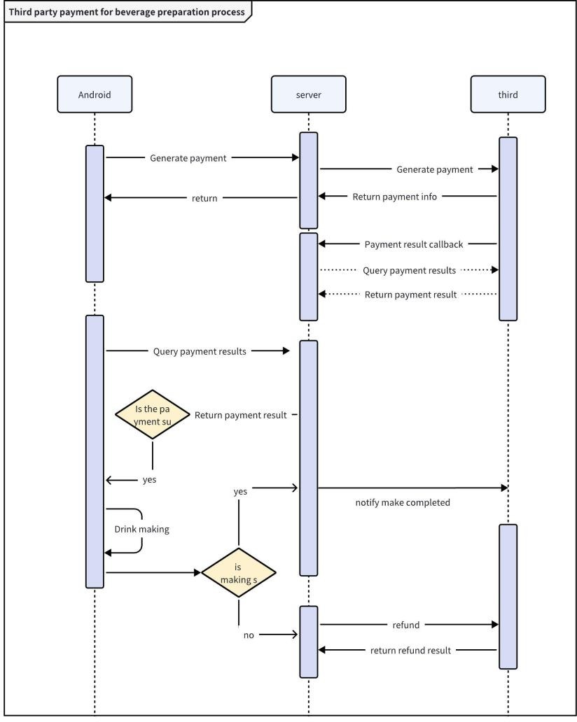
Descriptiion: GS provides Android and server-side services to facilitate order transactions and beverage preparation processes. Third party access requires payment and order placement (2.3.1), payment transaction notification (2.3.4), payment result query (2.3.2), payment refund (2.3.3), and payment refund order query (2.3.2)

interface design

Request public parameters

Public request header parameters
Description: The request header section must include the following authentication Request header parameters

name | type | requir  ed | defaul  t | notes

key | String | require d | key Can be generated in the management backend
key-md5 | String | require d | MD5(key + secret + timestamp)，key and secret  Can be generated in the management backend
timestamp | String | require d | Current timestamp

Public request return body
Description: The request return body includes the request status, request return information, and interface return value information
Return body parameters

name | type | requir ed | defaul t | notes
code | integer | require d |  | status code
msg | String | require d |  | Request to return information
data | Object | require d |  | Request to return body information
code description:

Status code | description | notes
200 | Request Success | success
400 | Business exception | Refer to the msg field for detailed exceptions

Third party provider

Card payment
Description:Card payment
Interface url： Request address provided by the third party Request method：Post
request data：

name | type | required | default | notes
orderNo | String | required |  | Transaction serial no
objectId | String | optional |  | Trading commodity ID
subject | String | required |  | Order information subject
attach | String | optional |  | Custom parameters for order information, feedback
totalAmount | String | required |  | Payment amount
cardNo | String | required |  | Card no
terminalId | String | required |  | Transaction terminal ID: Card reader payment is required for payment
notifyUrl | String | required |  | Payment callback address interface
Response Data：

name | type | required | default | notes
orderStatus | int | required |  | payment status (1- Pending Payment 2- Payment  Successful 3- Transaction  Failed 4- Pending Refund 5-Refund Completed 6- Time  Exceeded)

thirdOrderNo | String | required | Third party channel order  number

Generate payment QR code
Description: Request address provided by the third party Interface url：
Request method：Post
request data：

name | type | required | default | notes
orderNo | String | required |  | Transaction serial no
objectId | String | optional |  | Trading commodity ID
subject | String | required |  | Order information subject
attach | String | optional |  | Custom parameters for order information, feedback
totalAmou nt | String | required |  | Payment amount
thirdOrder No | String | required |  | Third party serial no
notifyUrl | String | required |  | Payment callback address interface
Response Data：

name | type | requi red | default | notes
qrUrl | Strin g | yes |  | QR code link
orderStatus | int | requir ed |  | payment status (1- Pending Payment 2- Payment

Successful 3- Transaction
Failed 4- Pending Refund 5-Refund Completed 6- Time Exceeded)
thirdOrderNo | Strin g | requir ed | Third party channel order number

Third party query payment result
Description:Third party query payment result
Interface url：Request address provided by the third party Request method：Post
request data：

name | type | required | default | notes
orderNo | String | required |  | Transaction serial no
thirdOrder No | String | required |  | Third party serial no
Response Data：

name | type | required | default | notes
orderNo | String | required |  | Transaction serial no
thirdOrderNo | String | required |  | Third party serial no
orderStatus | String | required |  | Payment status (1- Pending Payment 2- Payment  Successful 3- Transaction  Failed 4- Pending Refund 5-Refund Completed 6- Time Exceeded)
orderTime | String | required |  | Generate payment time
payTime | String | required |  | Actual payment time

totalAmount | String | required | Payment amount
channelUserId | String | optional | Payment user channel user ID, WeChat is openid, Alipay is userId,  For card payment users, the card number is used

Third party refund
Description:Third party refund interface
Interface url：Request address provided by the third party Request method：Post
request data：

name | type | require d | default | notes
refundNo | String | require d |  | Refund Transaction serial no
orderNo | String | require d |  | Transaction serial no
thirdOrderNo | String | require d |  | Third party serial no
refundAmount | String | require d |  | Refund transaction amount
refundReason | String | require d |  | Refund transaction reason
refundNotifyU rl | String | require d |  | Refund callback address interface
Response Data：

name | type | required | default | notes
refundNo | String | required |  | Refund serial no

orderNo | String | required |  | Interface return information
thirdOrderNo | String | required |  | Third party serial no
refundStatus | String | required | success | Refund status(success or fail)
refundTime | String | required |  | Refund time, Time format:yyyy-MM-dd HH:mm:ss
totalAmount | String | required |  | Original order amount
refundAmount | String | required |  | refund amount

Third party refund query result
Description:Third party refund interface
Interface url：Request address provided by the third party Request method：Post
request data：

name | type | require d | default | notes
refundNo | String | require d |  | Refund Transaction serial no
orderNo | String | require d |  | Original Transaction serial no
thirdOrderNo | String | optional |  | Original Third party serial no
Response Data：

name | type | required | default | notes
refundNo | String | required |  | Refund status
orderNo | String | required |  | Original

thirdOrderNo | String | required |  | Third party serial no
refundStatus | String | required | success | Refund status(pending,success or fail)
RefundMsg | String | required | success | Refund status detail(success or fail)
refundTime | String | required |  | Refund time, Time format:yyyy-MM-dd HH:mm:ss
totalAmount | String | required |  | Original order amount
refundAmount | String | required |  | refund amount

Third party notify payment result
Description:Third party notify payment result
Interface url：The field notifyUrl provided in section 2.3.1 or 2.3.2 Request method：Post
request data：

name | type | require d | default | notes
orderNo | String | require d |  | Transaction serial no
thirdOrderNo | String | require d |  | Third party serial no
orderStatus | String | optional |  | Payment status (1- Pending Payment 2- Payment  Successful 3- Transaction  Failed 4- Pending Refund 5-  Refund Completed 6- Time Exceeded)

orderTime | Generate payment time
payTime | Actual payment time
totalAmount | Payment amount
channelUserI d | Payment user channel user ID, WeChat is openid, Alipay is userId,  For card payment users, the card number is used
Response Data：

name | type | required | default | notes
orderNo | String | required |  | Original
thirdOrderNo | String | required |  | Third party serial no
returnCode | String | required | success | Notify status; success or fail

Third party refund notify payment result
Description:Third party notify payment result
Interface url：The field notifyUrl provided in section 2.3.1 or 2.3.2 Request method：Post
request data：

name | type | require d | default | notes
refundNo | String | require d |  | Refund Transaction serial no
orderNo | String | require d |  | Transaction serial no
thirdRefundN o | String | require d |  | Third party refund serial no

refundAmount | String | require d |  | Refund transaction amount
refundStatus | String | require d | success | Refund Transaction status,success ,waiting or fail
totalAmount | String | require d |  | Payment amount
refundTime | String | require |  | Refund Transaction time, Time format:yyyy-MM-dd  HH:mm:ss
Response Data：

name | type | required | default | notes
orderNo | String | required |  | Original
thirdRefundNo | String | required |  | Third party refund serial no
returnCode | String | required | success | Notify status; success or fail

Beverage preparation processes notify Third party
Description: Notify third parties upon completion of beverage preparation Interface url：Request address provided by the third party
Request method：Post
request data：

name | type | required | default | notes
orderNo | String | required |  | Transaction serial no
thirdOrderNo | String | required |  | Third party serial no
orderStatus | String | required | String | payment status (1- Pending Payment 2- Payment  Successful 3- Transaction  Failed 4- Pending Refund 5-Refund Completed 6- Time

 |  |  | Exceeded)
outStockStatu s | String | required | Delivery status for beverage preparation;1: Not shipped yet,2: Already shipped
outStockTime | String | required | Delivery time for beverage  preparation,Time format:yyyy-MM-dd HH:mm:ss
Response Data：

name | type | required | default | notes
orderNo | String | required |  | Transaction serial no
thirdOrderNo | String | required |  | Third party serial no
returnCode | String | required |  | Notify status; success or fail

Third party receive example message
Request data:
curl --location --request POST '${url}' \
--header 'timestamp: 1733446562634' \
--header 'key-md5: 9827b8674497a8d3b3bc9596ecea7d1a' \
--header 'key: 8727908ea7jnq' \
--header 'Content-Type: application/json' \
--data-raw '{ "objectType": 1,
"objectId": "1826089106430550018",
"price": 0.01,
"deviceId": "1767740916185841665",
"deviceNo": "1de2a9840e4f18ea", "merchantId": "1742482893377028098",
"payMethod": "wxpay", "wayCode": "qr"

}'

Response data:
{
"code": 200, "success": true, "data": {
"id": "1864912228214394882",
"paySettingMerchantId": "1123598821738675201",
"deviceId": "1767740916185841665",
"deviceNo": "1de2a9840e4f18ea", "objectType": 1,
"objectId": "1826089106430550018", "objectNo": "P202408211049047538", "orderTime": "2024-12-06 13:58:18",
"payTime": "2024-12-06 14:01:15",
"currency": "CNY", "sellerId": "1261526701",
"parentSellerId": "826539253110870", "orderNo": "A202412061358188410", "orderId": "1864912228214394883",
"payAmt": 0.01,
"receiveAmt": 0.01,
"tradeNo": "4200002450202412063058717692",
"status": 5,
"payWay": 1,
"outRequestNo": "RD202412061401042245",
"refundReason": "",
"refundSn": "", "returnAmt": 0, "payMethod": "wxpay", "wayCode": "qr",
"refundNo": "RD202412061401042245",

"refundStatus": "",
"failRemark": ""
},
"msg": "success"
}

